**Exercise 2: E-commerce Platform Search Function**

**Scenario:**

You are working on the search functionality of an e-commerce platform. The search needs to be optimized for fast performance.

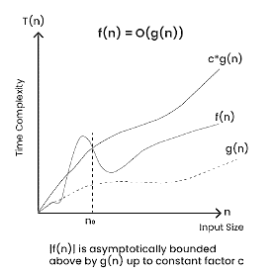**Steps:**

1. **Understand Asymptotic Notation:**
   * Explain Big O notation and how it helps in analyzing algorithms.

**Big-O**, commonly referred to as “**Order of**”, is a way to express the upper bound of an algorithm’s time complexity, since it analyses the worst-case situation of algorithm. It provides an upper limit on the time taken by an algorithm in terms of the size of the input. It’s denoted as **O(f(n))**, where **f(n)** is a function that represents the number of operations (steps) that an algorithm performs to solve a problem of size n.

* + Describe the best, average, and worst-case scenarios for search operations.

When analysing search operations, we consider three scenarios:

* **Best-case scenario**: The algorithm finds the target element in the first position it checks. This is the most optimistic scenario.
* **Average-case scenario**: The algorithm finds the target element after checking a moderate number of positions. This scenario is more realistic.
* **Worst-case scenario**: The algorithm checks all positions without finding the target element. This is the most pessimistic scenario.

1. **Analysis:**
   * Compare the time complexity of linear and binary search algorithms.

|  |  |  |  |
| --- | --- | --- | --- |
| **Algorithm** | **Best-case** | **Average-case** | **Worst-case** |
| Linear Search | O(1) | O(n) | O(n) |
| Binary Search | O(1) | O(log n) | O(log n) |

* + Discuss which algorithm is more suitable for your platform and why.

Based on the analysis we can see the financial has a much better time complexity than the linear search especially for the large input sizes so we can see the binary search is more suitable for our ecommerce platform such functionality. MC Binary search recruiters sorted in which can be maintained using efficient sorting algorithms like quick sort or mart sort. And we know the linear search is a simple implement but it’s a poor time tourism makes less suitable for large datasets so we should prefer the binary search algorithm in our ecommerce platform for searching 58 point ends a large number of products and their ids and their details.

However, if the input size is very small like less than 10 products leadership might be accepted due to simplicity and low overhead but ultimately choice is depend on the specific requirements of client platform